**PORT FOLIO**

**21CSC203P –ADVANCED PROGRAMMING PRACTICE**

**Aditya Muraleedharan**

**RA2411003010457**

**DEPARTMENT OF COMPUTING TECHNOLOGIES**



**FACULTY OF ENGINEERING AND TECHNOLOGY**

**SCHOOL OF COMPUTING**

**SRM INSTITUTE OF SCIENCE AND TECHNOLOGY**

**KATTANKULATHUR**

**OCTOBER 2025**

**MARK RUBRICS**

|  |  |
| --- | --- |
| **ABOUT ME(1)** |  |
| **PROJECT PROFILE(1)** |  |
| **GITHUB LINK-2.5 EACH (5)** |  |
| **CERTIFICATE AND ACHIEVEMENT (3)** |  |
| **E-CURRICULA (10)** |  |
| **HACKER RANK(5)** |  |

* About
* I’m **Aditya Muraleedharan**, an engineering student at **SRM Institute of Science and Technology, Kattankulathur**, and a member of **The Elecruisers**, SRM’s official eBAJA SAEINDIA team. I’m passionate about **Java development, automation, and AI-based systems**, and I enjoy building real-world projects like autonomous ATVs. My goal is to become a **skilled software and automation engineer**.
* Projects

The **Student Portal** project is a web-based application developed using **Java (JSP and Servlets)**, **Apache Tomcat**, and **MySQL** to demonstrate complete frontend, backend, and database integration. It allows students to log in securely, register for courses, and store their details in a connected MySQL database through JDBC. The project features a simple and responsive interface built with HTML, CSS, and Bootstrap, while the backend logic handles authentication and data submission using Servlets. Data is processed in real-time and stored in relational tables (users and courses), ensuring persistent storage. This project showcases the working of a mini web application running locally on Tomcat, highlighting concepts of **web architecture, database connectivity, and dynamic content rendering**—a practical demonstration of how modern web systems manage user interactions and data flow.

* GitHub

GitHub Profile: https://github.com/Ad1tya33

* Certificates & AchievementsA certificate of participation

  AI-generated content may be incorrect.

Software developer in abaja 2025  
  
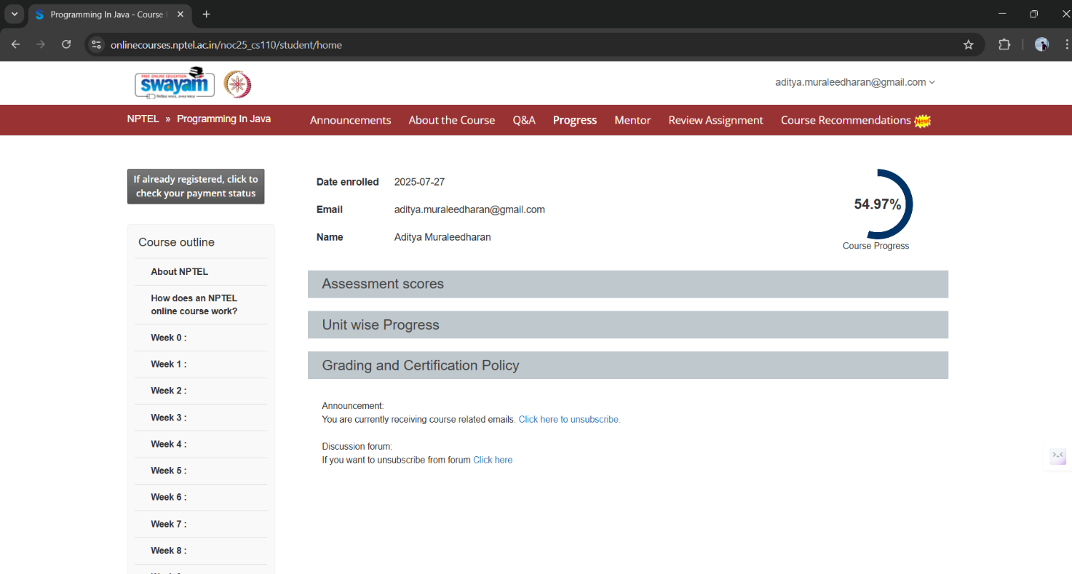

NPTEL Progress

* E-Curricula completion

Hacker rank problem completion:  
  
JAVA

PYTHON

